2a)

SELECT COUNT(OrderID) FROM Orders WHERE ShipperID =

(SELECT ShipperID FROM Shippers WHERE ShipperName = "Speedy Express")

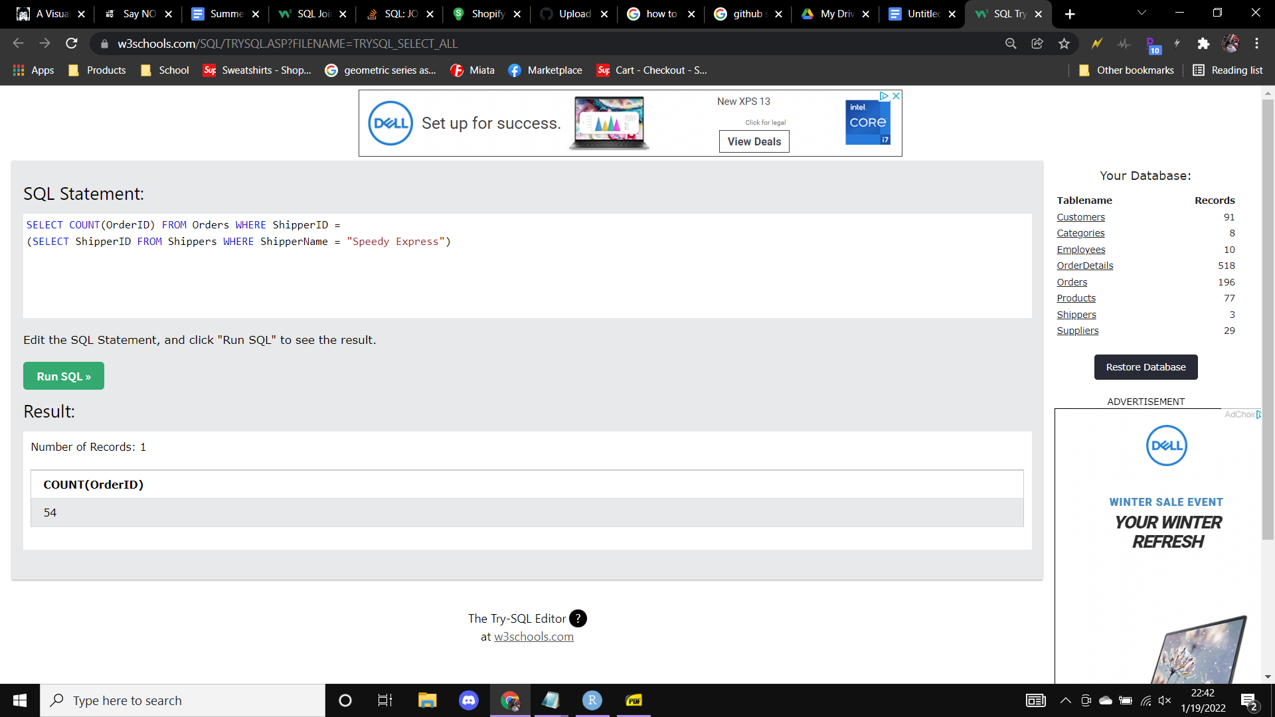

2b)

SELECT LastName FROM Employees

INNER JOIN (

SELECT EmployeeID, MAX(OrderCounts) FROM (

SELECT EmployeeID, COUNT(EmployeeID) AS OrderCounts FROM Orders GROUP BY EmployeeID

)

) MostSold ON Employees.EmployeeID = MostSold.EmployeeID

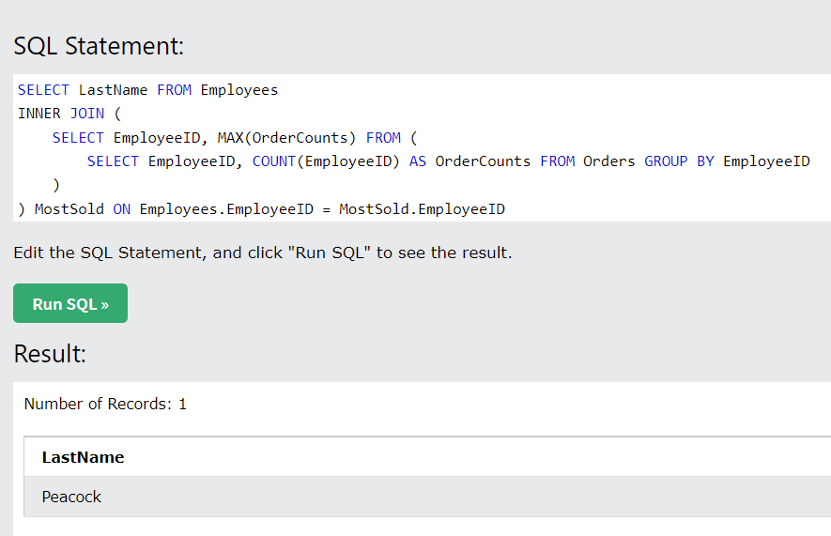

2c)

SELECT ProductName FROM Products

INNER JOIN (

SELECT ProductID, MAX(CombinedQty) FROM (

SELECT ProductID, SUM(Quantity) AS CombinedQty FROM OrderDetails

INNER JOIN (

SELECT OrderID, Orders.CustomerID FROM Orders

INNER JOIN (

SELECT CustomerID, Country FROM Customers WHERE Country = "Germany"

) German

ON Orders.CustomerID = German.CustomerID

) GermanyOrders ON GermanyOrders.OrderID = OrderDetails.OrderID

GROUP BY ProductID ORDER BY CombinedQty DESC

)

) MostOrdered ON Products.ProductID = MostOrdered.ProductID

